Abstract Expressionism Word Count: 1053

Abstract Expressionism was a group of loosely affiliated artists that came together in the early 1940s, primarily in New York City. Abstract Expressionist artists, such as Jackson Pollock, Willem de Kooning, Franz Kline, Robert Motherwell, Mark Rothko, Barnett Newman, and Lee Krasner, among others, pursued radically new forms to express a deep sense of meaning. Flourishing during the 1940s and the 1950s, Abstract Expressionism gained recognition as the first specifically American movement to achieve an international reputation, placing New York at the center of the art world, a position previously reserved for Paris. Since most first-generation Abstract Expressionists lived in New York City, the movement was also known as ‘The New York School’. Critics Harold Rosenberg and Clement Greenberg preferred the names “Action Painting,” “American-type Painting,” and “painterly abstraction”. The term Abstract Expressionism emerged in Germany in 1919 in reference to German Expressionism. Alfred Barr used it for the first time in the U.S. in 1929 to describe the paintings of Vasily Kandinsky. In 1946, Robert Coates adopted the term to designate contemporary American painting, describing Hans Hofmann as representative “of what some people call the spatter-and-daub school of painting and I [Coates]… have christened abstract expressionism.” Despite the fact that most Abstract Expressionists rejected labels, the term remained. The phrase served to unite the two dominant aspects of Abstract Expressionist art: a non-figurative commitment that reduced representational objects to basic geometric forms (abstraction) and the improvisational brushstrokes expressing emotion or conceptual states (expressionism).

Never a formal affiliation, Abstract Expressionism encompasses a variety of styles and represents an artistic attitude, rather than a single form of expression. What unites the distinct personalities within the movement is their rejection of overt political messages, a desire to express emotional and spiritual truths, and a search for universal or morally significant themes often implemented on a grand scale. Not all works were abstract and emotionally expressive; however, all Abstract Expressionists valued what was termed “authentic individuality” and improvisation. Emblematic of their approach are the incorporation of chance and accidents that occur during the painting process; an adoption of “all-over” compositions in which all parts of the canvas are of equal value; an emphasis on the process or act of painting used as a way of communication; and the focus on the surface of the canvas, where loose strokes, gestural marks, or planes of colour convey expression. A commitment to truthfulness, emotion, and profound themes unites diverse artistic approaches ranging from the calligraphic, poured and dripped paintings of Jackson Pollock to the soft-edged and meditative rectangles of Mark Rothko.

Based on trends within the movement, Abstract Expressionism came to be divided into two groups: Gestural (Action) Painting and Color Field Painting. Gestural Painting includes techniques that use pronounced, often energetic, brushstrokes as a way of expression, such as pouring and dripping thinned paint onto raw canvas laid on the ground (Pollock) or dynamic gestures articulating powerful iconic figures and abstract imagery (De Kooning, Franz Kline, and Lee Krasner). Color Field Painting emphasizes the lyrical effects and expressive capacities of colour—often poured or stained directly onto the canvas—to conjecture a vision of the “sublime” or achieve a cerebral and reflective state of mind. The latter group encompasses methods such as the quiescent, intensely coloured landscape-like fields of Mark Rothko or the vast areas of unmodulated, flat, and stained colour of Barnett Newman, Helen Frankenthaler, Kenneth Noland, and Clyfford Still.

Most Abstract Expressionists began working in the 1930s, so the Great Depression and its aftermath are paramount to understanding their artistic choices. Many met through government relief programs such as the Depression-era WPA (Works Progress Administration), which employed artists to paint murals in public spaces. Although the experience encouraged the future Abstract Expressionists to paint on a large scale, the artists abandoned the popular movements of the time—Regionalism and Socialist Realism—and their corresponding ideologies (nationalism and socialism) in search of universal art free of totalitarian gist, overt politics, and provincialism. In the eyes of post-war and Cold War audiences, Abstract Expressionism voiced the inner turmoil and dark mood of the time and embodied the American spirit—monumental, romantic, and symbolic of individual freedom. At the same time, the artists enacted a sense of community—redolent of a common philosophy and social responsibility—as they frequented various locales in New York City to engage each other’s work and discuss topics such as existentialism, “gestalt therapy,” and Zen Buddhism.

Among various post-war factors, it was the vibrant New York art scene and the assimilation of European modernism that set the stage for Abstract Expressionism’s break with traditional painting. American artists encountered European modernism—particularly, Surrealism, Cubism, Dada, and Geometric Abstraction—in the galleries of an expanding network of museums such as the Museum of Modern Art and newly established galleries, such as Peggy Guggenheim’s The Art of this Century. The primary source of inspiration, however, came with the influx of expatriate artists including Marcel Duchamp, André Masson, and Piet Mondrian who crossed the ocean to escape Hitler-dominated Europe. Abstract Expressionism benefited particularly from direct contact with Surrealism (Max Ernst), De Stijl (Mondrian), and artistic philosophies concerned with the physicality of paint and the possibilities of abstraction (Hans Hofmann and Arshile Gorky). Surrealism impacted Abstract Expressionism with its interest in the psychoanalytic theories of Sigmund Freud and Carl Jung, as well as its incorporation of chance, improvisation, and use of automatism to tap into one’s subconscious.

In addition to the above-mentioned male artists, Abstract Expressionism included notable women such as Lee Krasner, Hedda Sterne, Joan Mitchell, Helen Frankenthaler, and Louise Bourgeois.

**References and further reading**

Anfam, D. (1990). *Abstract Expressionism*. London: Thames and Hudson.

Auping, M. (1987). *Abstract Expressionism: the Critical Developments*. New York: Abrams.

Craven, D. (1999). *Abstract Expressionism as Cultural Critique*. Cambridge: Cambridge University Press.

Frascina, F. (ed.) (1985). *Pollock and After*. London: Harper and Row.

Gibson, A. E. (1997). *Abstract Expressionism: Other Politics.* New Haven: Yale University Press.

Guilbaut, S. (1983). *How New York Stole the Idea of Modern Art.* Chicago: University of Chicago Press.

Polcari, S. (1991). *Abstract Expressionism and the Modern Experience.* Cambridge: Cambridge University Press.

Sandler, I. (2009). *Abstract Expressionism and the American Experience: A Reevaluation.* Lenox: Hard Press.

Seitz, W. C. (1983). *Abstract Expressionist Painting in America.* Cambridge: Harvard University Press.

Siegel, K. (2011). *Abstract Expressionism.* London: Phaidon Press.

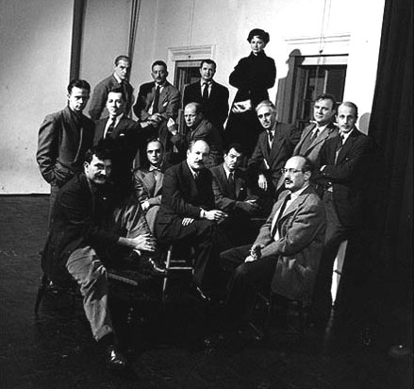

“The Irascibles,” *Life Magazine*, 1951. Nina Leen Time Life Pictures/Getty Images. <http://life.time.com/photographers/photographer-spotlight-nina-leen/attachment/08_00986802/>

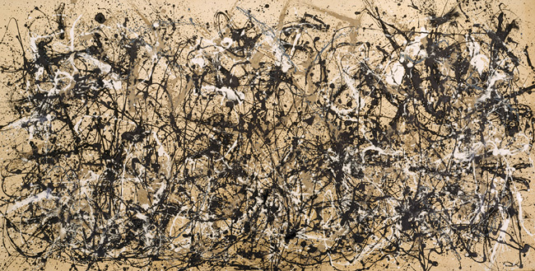

Jackson Pollock, *Autumn Rhythm (Number 30)*, 1950. Enamel on canva. 105 x 207 in. (266.7 x 525.8 cm). <http://www.metmuseum.org/toah/works-of-art/57.92>

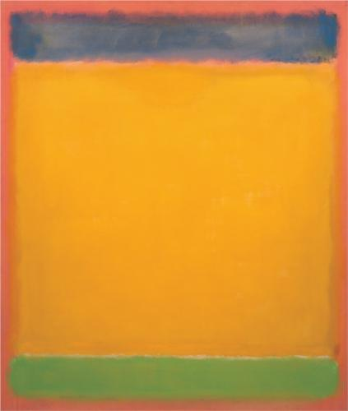

Mark Rothko, *Untitled (Blue, Yellow, Green on Red)*, 1954. Oil on canvas, 77 3/4 × 65 1/2 in. (197.5 × 166.4 cm). Whitney Museum of American Art, New York; gift of The American Contemporary Art Foundation Inc., Leonard A. Lauder, President  2002.261

<http://whitney.org/Collection/MarkRothko/2002261>